The Office of Acquisition and Logistics Management Newsletter

2020 3rd Quarter

Launch of NBS Buyer Simplified Acquisition – Systems II Course
The NIH Business System (NBS) and Office of Acquisition & Logistics Management (OALM) are excited to announce the launch of a modular computer-based course, NBS Buyer Simplified Acquisition – Systems II. The course will provide users with an on-demand learning opportunity while also serving as a resource bank for NBS users to reference in the future.
NBS Buyer Simplified Acquisition – Systems II, now available on the HHS Learning Portal, is comprised of five required modules covering aspects of the simplified acquisitions lifecycle and one optional section that provides detailed troubleshooting instructions. It is highly recommended that you review the optional module before beginning the required course material.
The course is designed to instruct new and existing PRISM users on how to use the NBS Buyer Simplified Acquisition System to effectively create and manage orders throughout the award lifecycle.
The course includes five required modules:
Module 1 – NIH Business System and Simplified Acquisition Overview
Module 2 – Acquisition Planning and Pre-Award
Module 3 – Creating Awards
Module 4 – Administering and Modifying Awards
Module 5 – Closeout
Recommended Content– Course Troubleshooting Tip Sheet
Within each module, users will progress through lessons and exercises that teach the necessary information to perform key tasks related to Simplified Acquisitions within the NBS. Each module concludes with a short quiz designed to help reinforce concepts and processes reviewed in the module. To receive credit, users must score 100% on the quizzes; completion of each course module; and a final assessment score of 80% or higher to successfully complete the course.
Basic Simplified Acquisition training is a required prerequisite because of the advanced procurement concepts and terminology used in this course. Basic Simplified Acquisition is offered through various channels including FAITAS (free – Course # FQN 425), the NIH Training Center (cost – Course # NIHTC9530) and other vendors (see https://oalm.od.nih.gov/acp_training for list). For more information regarding acquisition training, please contact acp@nih.gov.
You can register for the new Buyer Simplified Acquisition Course on the HHS Learning Portal. The course information is provided below:
Course Name: NBS Buyer Simplified Acquisition – Systems II
Course ID: NBS BSA-SYSTEMS II
ID #: 00205901
The course will take approximately 8 hours to complete. Learners will receive 8 CLPs for successfully completing the course.

Section 889 Part B Prohibition on Contractors that Use Certain Telecom Equipment and Services Now in Effect
In FY2019, the National Defense Authorization Act (NDAA) set forth two prohibitions contained in Section 889(a)(1)(A) and (B) regarding certain telecommunications and video surveillance equipment and services (telecom).
Part A went into effect on August 13, 2019 and mandated that the Government may not obtain through a contract or other instrument certain telecommunications equipment or services produced by the following companies or their subsidiaries and affiliates:
- Huawei Technolgies Company
- ZTE Corporation
- Hytera Communications Corporation
- Hangzhou Hikvision Digital Technology Company
- Dahua Technology Company
After Part B went into effect on August 13, 2020, the Government also may not contract with an entity that uses telecommunications equipment or services, as a substantial or essential component of any system, or as critical technology as part of any system, produced by any of the companies listed above. Part B applies to every sector, regardless of what a company makes or sells.
Both Part A and B have been added to the FAR (FAR 4.2102), and both parts also apply to commercial items (FAR 12.301(d)(6)) as well as micro-purchases (FAR 13.201(i)). New representation provisions have been added at FAR 52.204-24 and 52.204-26, as well as a new reporting clause at FAR 52.204-25. Those provisions and clauses allow for vendors to represent whether they do or do not provide or use prohibited telecommunications equipment and services.
For more information and resources, please check out the DSAPS SharePoint site at https://oalmsps.od.nih.gov/OAMP/DSAPS/ASRB/SAPhD/SitePages/Home.aspx, under Tools (Best Practices), and in the “889 Prohibits Telecom Equipment & Services Huawei, ZTE, Dahua, Hytea, & Hangzhou” folder. This site will continue to be updated as more information comes in.

COVID-19 Contract Admin Support
On January 31, 2020, in response to the Coronavirus Disease 2019 (COVID-19), Secretary Azar of the Department of Health and Human Services, under section 319 of the Public Health Service Act, determined that a public health emergency exists and has existed since January 27, 2020, nationwide (HHS Public Health Emergency Determination https://www.phe.gov/emergency/news/healthactions/phe/Pages/2019-nCoV.aspx).
In addition, several acquisition policies were distributed across the federal government. These new COVID-19 policies provided emergency acquisition flexibilities and framework, which afforded the federal acquisition community expedience in federal procurement processing. As a result, the government spending trends spiked tremendously in response to COVID-19 response, requiring federal acquisition support.
As early as March 2020, the Office of Logistics Acquisitions and Operations (OLAO), Office of Acquisitions (OA), began responding to the NIH acquisition needs in a variety of ways. Our office quickly adopted and utilized the new policy framework for meeting the various NIH acquisition needs. Since several new contracts have recently been written, as well as so many of the existing contracts have continued operational support in order to accomplish the NIH Mission during these crisis times, our staff has been responding to questions from customers regarding ‘How do we manage the work while we all are teleworking?’ We have illustrated some of the common themes:
1. | Contract/Task Order oversight by the Contracting Office Representative (CORs), particularly for Labor Hour Requirement: It has become very challenging to physically observe the work efforts of contractor employees, while we all are working remotely. One recommendation is to check-in regularly with the contractor Program Manager concerning progress on work. Be sure to carefully review any deliverables such as reports to verify that work is progressing.  Another recommendation concerns invoice processing. Invoice review is an important responsibility of a COR; particularly for labor hour type contracts and task orders. If the hours reported do not seem to match the work output, the COR is empowered to question and/or reject the hours reported with the contractor. In addition, please inform the contracting officer if there are any invoice discrepancies.
2. | Avoiding the pitfalls of personal services: As a COR, your responsibility is to manage the technical side of the contract/order; not manage contractor employees. If there are contractor employee issues, bring them to the attention of the contractor employer (such as the contractor Program Manager) and the contracting officer for resolution.
3. | Same standards apply on contract whether in person or virtual: Keeping in mind that work efforts must continue, we have encouraged our CORs to get creative on service delivery. Where applicable, we have been working with CORs to revise the contract scope for optimal service delivery in this virtual environment.
We are currently living and working through an unprecedented time in modern US history. With proper communications, patience, and creativity your acquisition can succeed through challenging periods.

New OLAO Office of Acquisition Director
In July 2019, the Office of Logistics, Acquisitions and Operations (OLAO) welcomed a new Director of the Office of Acquisitions. OLAO-OA serves as one of three divisions under the OLAO umbrella. Ms. Darnese Wilkerson immediately engaged with OLAO customers and stakeholders and to begin decoding longstanding concerns, in order to effectively make a difference in the operational interworking of the organization. While Ms. Wilkerson is new to the NIH family, she has been with the federal government since 2002, working for several federal agencies in the contracting capacity. Prior to her federal career, she worked with various private industry, government contracting firms (Booz, Allen & Hamilton, Lockheed Martin, and a few others).
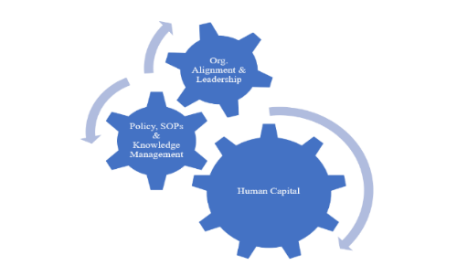
Ms. Wilkerson quickly introduced her leadership platform entitled the VISION2020, which represents a lot of the concepts suggested in the General Accountability Office (GAO) “Best Practices” in Leading Acquisition Management ( https://www.gao.gov/key_issues/leading_practices_acquisition_management/issue_summary#t=0). It is essential for federal acquisition contingencies to be managed in an efficient and effective manner, based on four interrelated elements that promotes an efficient and accountable acquisition environment; Organizational Alignment and Leadership, Policies and Processes, Human Capital's Acquisition Workforce, Knowledge and Information Management.
Therefore, the new direction consists of three (3) main points: (1) Staff Development to build office capacity, (2) Policy Enhancement to improve consistency, (3) Leverage Technology to improve efficiency. As suggested by the GAO Best Practices, the organization established a clear Mission and Vision for the organization, which serves as the nucleus for the organization’s new direction.
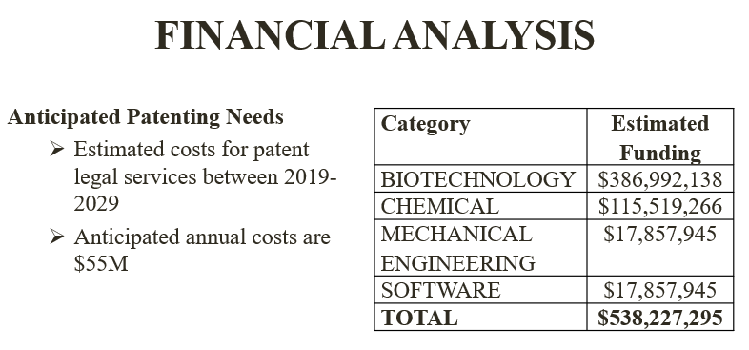
With only a few short months remaining in this fiscal year, the office is on par to award record numbers this Fiscal Year 2020. For Fiscal Year 2019, the OLAO-OA processed nearly 13,000 actions valued at nearly $500 million; contract awards that are critical to NIH’s Mission. This year, the organization awarded a new NIH-wide contract vehicle for Patent and Legal Support. This contract is in support of Patenting at NIH for its novel discoveries that could lead to inventions under patent statutes (35 U.S.C.). Inventions may be patented in the U.S. and worldwide. Patenting and licensing of Government inventions is essential to entice commercial entities to invest the resources necessary to develop discoveries and technologies for public access. Efforts may include, for example, biochemistry, molecular biology, nanotechnology as it effects biological systems, diagnostics, therapeutics, cell biology, genetics/genomics/epigenetics, proteomics, recombinant technology, gene editing, anatomy and physiology, immunology, and vaccines.
In addition to the office’s mission of awarding contract solutions that create economies of scale to be leveraged for customer-focused mission support, the office has also been very busy in Corona Virus (COVID) support, to include some of the Department’s communication needs, as well as critical NIH operational support needs. As the office manages the various challenges of the virtual workplace, OLAO-OA remains engaged and poised to respond to NIH Acquisition Workforce’s contracting needs.

OLAO-OA Engages in NIH and HHS Agency-wide

Mission Support Opportunities
Those are among the several agency-wide mission support programs offered by NIH and HHS:
- Long-term Administrative Support Contract (LTASCII)
- BPSS - Business and Profession Support Services contract for the support of NIH wide professional services.
- PICs - Public Information and Communication services contract for support of NIH Wide communication efforts.
- NIH Conference, Administrative and Travel Services Contract (NIHCATSIII)
LTASC II
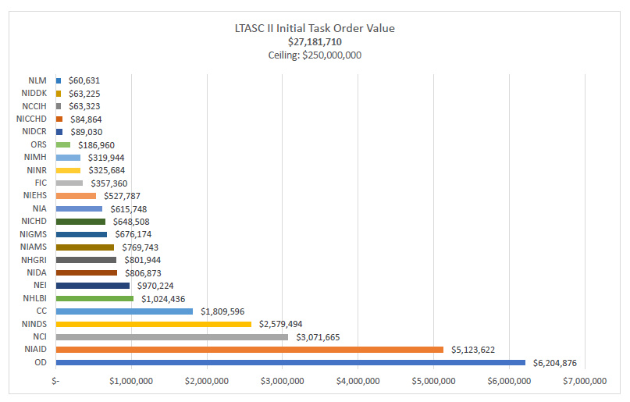
The Long-Term Administrative Support Contract II (LTASC II) is a small business set aside IDIQ contract that can be used to obtain commercially provided administrative services on a long-term basis (e.g. at least 12 months on a task order basis) across all Institutes, Centers and Offices (ICs) within the National Institutes of Health (NIH). The LTASC contract vehicle was established in 2010 as a result of the NIH’s need for assistance to assess options to address A-76 competitive sourcing requirements for positions under evaluation. Administrative duties under LTASC II include a range from generic clerical skills (e.g. fielding phone calls, scheduling meetings, taking minutes, generating reports) to administrative duties for executive management. LTASC II will expire in early January 2021, and the LTASC Team is working towards the next iteration – LTASC III.

NIHCATS III
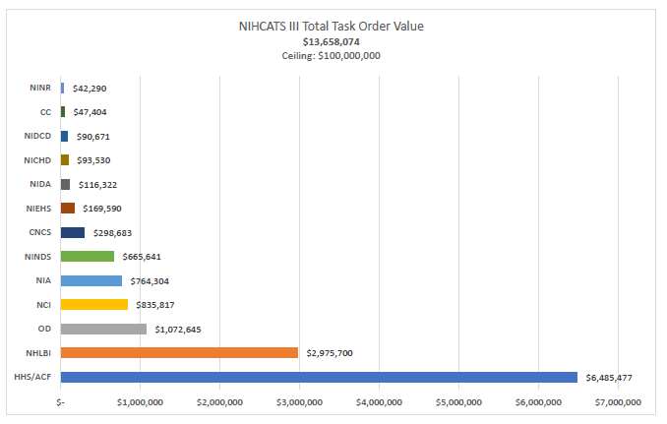
The National Institutes of Health Conference, Administrative, and Travel Services (NIHCATS) III contract vehicle is a small business set aside IDIQ that offers a wide range of administrative, meeting, conference, and travel support services in the U.S. and abroad for all federal agencies. The mission of the NIHCATS III is to provide the right services, qualified external talent, and facilities not otherwise provided by the Government for customers across the federal space. In fact, NIHCATS II is HHS’s strategic sourcing contract for conference support, and its use was encouraged by HHS leadership.
PICS II
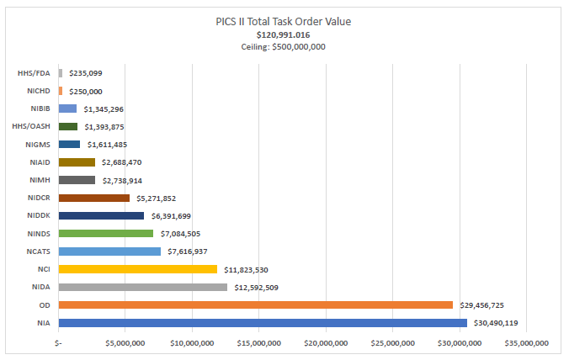
The Public Information and Communication Services (PICS) II contract vehicle is a small business set aside IDIQ that offers ICs at the NIH communications and outreach; graphic design; web and database; materials development and distribution; and exhibit support. The mission of PICS II is to achieve and maintain high quality performance in the areas of media, communication, information dissemination and technology. PICS II is the vehicle OLAO uses to solicit superior communications services, especially where this expertise does not exist in-house. The PICS contract vehicle was established in tandem with the NIH communications community to ensure future customers would receive the wide range of services needed in the ever-evolving modern communications landscape.

NIHBPSS II
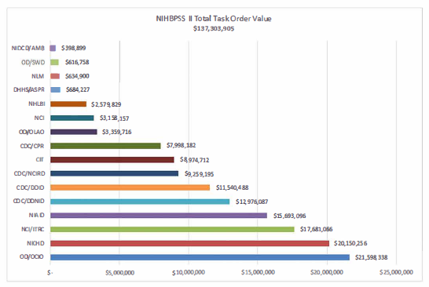
The NIH Business and Professional Support Services II (NIHBPSS II) contract is a multiple award partial small business set aside IDIQ available to all ICs and offices within the NIH to purchase business and professional support services on a task order (TO) basis. NIHBPSS II affords customers the ability to order services after requirements materialize, providing NIH with flexibility in both quantities and delivery scheduling.

Path to Excellence and Innovation Program

Enters Next Phase in Fiscal Year 2021
With the beginning of fiscal year (FY)21 in October, the Path to Excellence and Innovation (PEI) program will begin offering more extensive acquisition training and technical assistance for Historically Black Colleges and Universities (HBCUs). The expanded program also will foster partnerships between HBCUs and businesses.
The National Institutes of Health (NIH) Office of Acquisition and Logistics Management (OALM) launched the PEI program in response to Executive Order (EO) 13779: The White House Initiative to Promote Excellence and Innovation at Historically Black Colleges and Universities. This EO issued in 2017 encourages federal agencies to assist in strengthening HBCUs’ ability to equitably participate in federal programs, explore new ways to improve the relationship between the federal government and HBCUs and establish how each respective agency intends to increase the capacity of HBCUs to compete effectively for grants, contracts, and cooperative agreements.
During the PEI program’s pilot phase, six HBCUs were selected to participate in a series of workshops designed to empower them with the knowledge, resources and skills needed to effectively and consistently compete for and win partnership opportunities within the NIH. In FY 2021, the program will begin accepting applications from additional procurement-ready HBCUs. The focus of the next phase will be on increasing revenue to these institutions. Currently, the NIH awards less than 1% of the agency’s contract dollars to HBCUs. The goal is to increase that spending to 5%.
Toward that end, the expanded PEI program curriculum will emphasize delivering capability briefings to the NIH centers, preparing compelling and compliant proposals to solicitations, as well as developing the infrastructure needed to sustain the acquisition life cycle. Participants will be matched with business partners that have HHS/NIH past performance as a prime or subcontractor. The teams will have access to an acquisition database and together they will identify opportunities and submit proposals. The Small Business Program Office (SBPO) will provide feedback and guidance following the outcome notification on submissions. The expanded program also will feature a Technical Assistance Center designed to provide infrastructure support to HBCUs.
Ms. Diane J. Frasier will continue to house the PEI program under the Small Business Program Office with Ms. Annette Owens-Scarboro maintaining her role as the program manager. Supreme Solutions Inc., an 8(a) vendor awarded a support contract to assist in the development of the pilot, will remain in that capacity for the next phase of the PEI program.

NITAAC: Do You Have a Project That Needs to Get Done, But…
- You don’t have enough time?
- You don’t have enough of or the right resources?
- You would like to do something in a new way, with a fresh perspective?
- You are an expert and would like to share your expertise with junior acquisition professionals?
- _______________ (fill in the blank)

This was NITAAC last month. NITAAC posted a micro-project on Open Opportunities entitled, “Seeking Dynamic Feds for User Acceptance Testing (UAT) for NIH NITAAC.” Within three days we had all 10 participants we were looking for.
Through this micro-project NITAAC was able to reach out to a multitude of different agencies and develop a UAT team for a broader perspective on our upcoming new CIO-CS catalog. We value this feedback as we create our GWACs for federal use. This project allowed us to rapidly gain testers, adjust to the feedback received and it allows us to release the new catalog the day after the testing closed. This entire Open Opps project has supported NITAAC to efficiently stay on schedule, verify data and ensure our catalog is appealing. All of this helps us stay at the leading edge of fulfilling our mission.
We understand that Open Opps is new to many and it may be to your organization as well. We encourage your organization’s leadership to request training at openopps@usajobs.gov. A training session may also help quickly address questions from every angle. In addition to offering group training, each community has a manager who can provide coaching to help you be successful on our platform. In a nutshell, we can help you leverage our innovative platform and the skillsets of federal employees across the gamut for mission success.
What projects could OALM members succeed at with the help of Open Opps?
Who do I contact at NIH? Kelly Lael is an assisted acquisition contracting officer at NITAAC. She is passionate about solving problems in an innovative manner that highlights the strengths and talents of federal employees. This is one reason she continues to be a community manager for acquisitions in Open Opportunities. Would you like to know more? Please contact Kelly at 301-402-5683 or kelly.lael@nih.gov. Please visit https://openopps.usajobs.gov/ and set up an account and begin exploring this platform.

COVID-19 Procurement Guidance
A COVID-19 Procurement resource page has been established for the NIH acquisition community. This guidance is maintained and will be supplemented as we continue to learn more about how this situation will affect the administration of procurement actions at the NIH. Please visit the ASRB SharePoint home page for more information.

Recap Corner
Below is a recap of recent OALM communications to the NIH acquisition workforce
ID | Title | Date | Purpose
20-43 | Resolving FY 2015 Canceling Year Lines | 5/18/2020 | Certain appropriations are available for obligation for a specific period, i.e., annual and multi-year appropriations. NIH’s approach is to have these lines resolved by July 31, 2020.
20-44 | Resolving FY 2015 Canceling Year Lines | 5/26/2020 | Certain appropriations are available for obligation for a specific period, i.e., annual and multi-year appropriations. NIH’s approach is to have these lines resolved by July 31, 2020.
20-45 | Efficient Spending Policy: Guidance on Conferences and Virtual Events During COVID-19 Emergency | 5/28/2020 | Due to the COVID-19 emergency, many NIH-hosted and non-NIH-hosted events have been cancelled or converted to virtual meetings. Attached is a collection of guidance covering the different parts of the Efficient Spending Policy
20-46 | Resolving FY 2015 Canceling Year Lines | 6/1/2020 | Certain appropriations are available for obligation for a specific period, i.e., annual and multi-year appropriations. NIH’s approach is to have these lines resolved by July 31, 2020.
20-47 | Resolving FY 2015 Canceling Year Lines | 6/8/2020 | Certain appropriations are available for obligation for a specific period, i.e., annual and multi-year appropriations. NIH’s approach is to have these lines resolved by July 31, 2020.
20-48 | Extension of FPDS National Interest Action Code for COVID-19 | 6/11/2020 | The National Interest Action (NIA) Code for COVID-19 is being extended to continue to track acquisition costs related to the COVID-19 efforts in FPDS.
20-49 | Resolving FY 2015 Canceling Year Lines | 6/14/2020 | Certain appropriations are available for obligation for a specific period, i.e., annual and multi-year appropriations. NIH’s approach is to have these lines resolved by July 31, 2020.
20-50 | Form 653 Small Business Review for COVID-19 actions | 6/15/2020 | The SBCX system’s Form 653 small business review workflow has been updated to reflect the new Simplified Acquisition Threshold (SAT) as outlined in Acquisition Alert 2020-06
20-51 | FPDS Scheduled Maintenance | 6/19/2020 | FPDS scheduled maintenance downtime
20-52 | Resolving FY 2015 Canceling Year Lines | 6/22/2020 | Certain appropriations are available for obligation for a specific period, i.e., annual and multi-year appropriations. NIH’s approach is to have these lines resolved by July 31, 2020.
20-53 | FPDS Scheduled Maintenance | 6/25/2020 | FPDS scheduled maintenance downtime
20-54 | Resolving FY 2015 Canceling Year Lines | 6/292020 | Certain appropriations are available for obligation for a specific period, i.e., annual and multi-year appropriations. NIH’s approach is to have these lines resolved by July 31, 2020.
20-55 | New FPDS Field 10Z “Source Selection Process.” | 6/29/2020 | Effective June 27, 2020, the Federal Procurement Data System-NG (FPDS-NG) added a new field 10Z, “Source Selection Process.”
20-56 | Launch of NBS Buyer Simplified Acquisition – Systems II course Information | 6/30/2020 | The NIH Business System (NBS) and Office of Acquisition & Logistics Management (OALM) are excited to announce the launch of a modular computer-based course, NBS Buyer Simplified Acquisition – Systems II.
20-57 | Resolving FY 2015 Canceling Year Lines | 7/6/2020 | Certain appropriations are available for obligation for a specific period, i.e., annual and multi-year appropriations. NIH’s approach is to have these lines resolved by July 31, 2020.
20-58 | Resolving FY 2015 Canceling Year Lines | 7/13/2020 | Certain appropriations are available for obligation for a specific period, i.e., annual and multi-year appropriations. NIH’s approach is to have these lines resolved by July 31, 2020.
20-59 | Resolving FY 2015 Canceling Year Lines | 7/20/2020 | Certain appropriations are available for obligation for a specific period, i.e., annual and multi-year appropriations. NIH’s approach is to have these lines resolved by July 31, 2020.
20-60 | FPDS Scheduled Maintenance | 7/23/2020 | FPDS scheduled maintenance downtime
20-61 | Resolving FY 2015 Canceling Year Lines | 7/27/2020 | Certain appropriations are available for obligation for a specific period, i.e., annual and multi-year appropriations. NIH’s approach is to have these lines resolved by July 31, 2020.
20-62 | DEADLINE TOMORROW! Resolving FY 2015 Canceling Year Lines | 7/30/20 | Certain appropriations are available for obligation for a specific period, i.e., annual and multi-year appropriations. NIH’s approach is to have these lines resolved by July 31, 2020.
20-63 | DEADLINE TODAY! Resolving FY 2015 Canceling Year Lines | 7/31/20 | Certain appropriations are available for obligation for a specific period, i.e., annual and multi-year appropriations. NIH’s approach is to have these lines resolved by July 31, 2020.

Acquisition Training Information

Acquisition Training at NIH
Acquisition training classes that are offered by the NIH Training Center can be accessed at the following link: Acquisitions Management Courses

Federal Acquisition Certification Coursework
CON courses and other Federal Acquisition Certification required courses can be found at the NIH Training Center, Federal Acquisition Institute, and Defense Acquisition University.
Section 508 Accessibility Training
Section 508 Accessibility Training courses can be accessed at: CIT Section 508 Accessibility Training Website.

Green Purchasing Training
Green Purchasing Training and other Green Training courses can be found at: OALM Green Purchasing Website.

NIH Blanket Purchase Agreement (BPA) Lists Available Online

Lists of all NIH Blanket Purchase Agreements (BPAs) can be found at the NIH Blanket Purchase Agreement webpage.
This location contains Two BPA Lists:
1. Complete vendor alphabetical list;
2. Vendor list sorted by commodity; and
If you have any questions or need further clarification, please contact the BPA helpline at 301-496-5212 or email.

THANKS!
We would like to thank all those who contributed to this and future editions of the OALM Newsletter.
The OALM Newsletter will be published four (4) times in calendar year 2020. We encourage staff to submit articles that would be of interest to our readers. We will do our best to include such articles in future editions of the OALM Newsletter.
Please address all correspondence to the editors: Milton Nicholas, NicholaM@od.nih.gov, Michele McDermott, McDermottMl@od.nih.gov, Jesse Lee, Jesse.Lee2@nih.gov, or Barry Solomon, SolomonBJ@od.nih.gov.
If you have any questions or comments regarding the information, policy and/or procedures published in this issue, you may contact Barry Solomon at the e-mail address above. For future editions or comments please contact the Simplified Acquisitions Helpline on 301-496-0400 or via e-mail at OALMnewsletter@mail.nih.gov and you will be referred to the appropriate editor.

